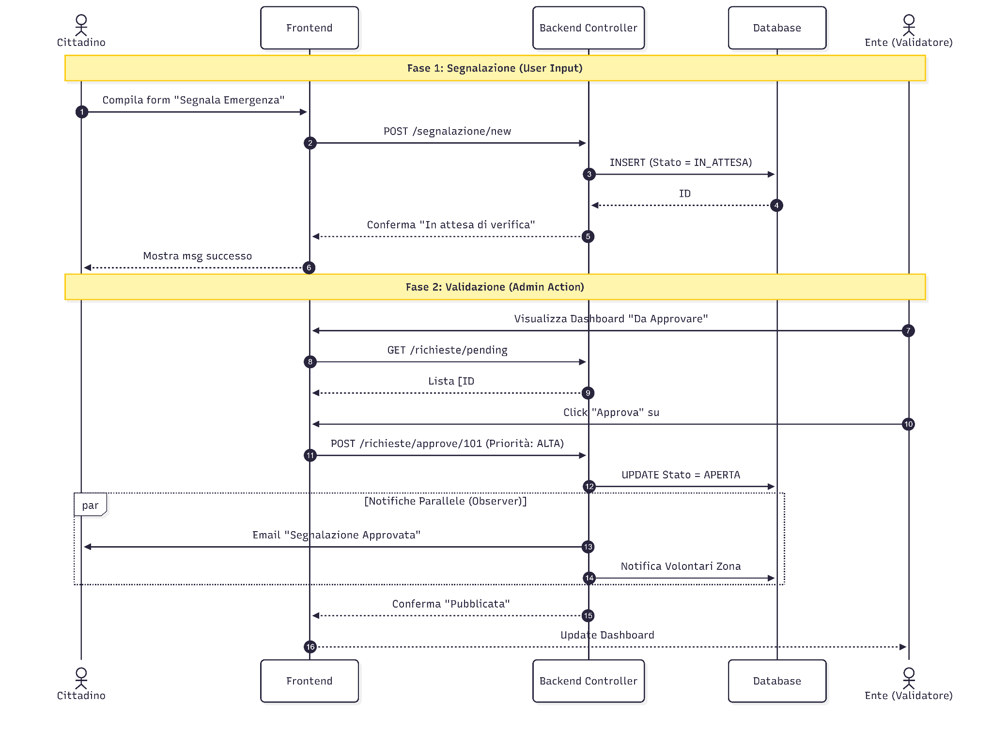
1. Sequence Diagram (Per SDD)

2. State Diagram (Per SDD)
Mostra il nuovo stato IN ATTESA.
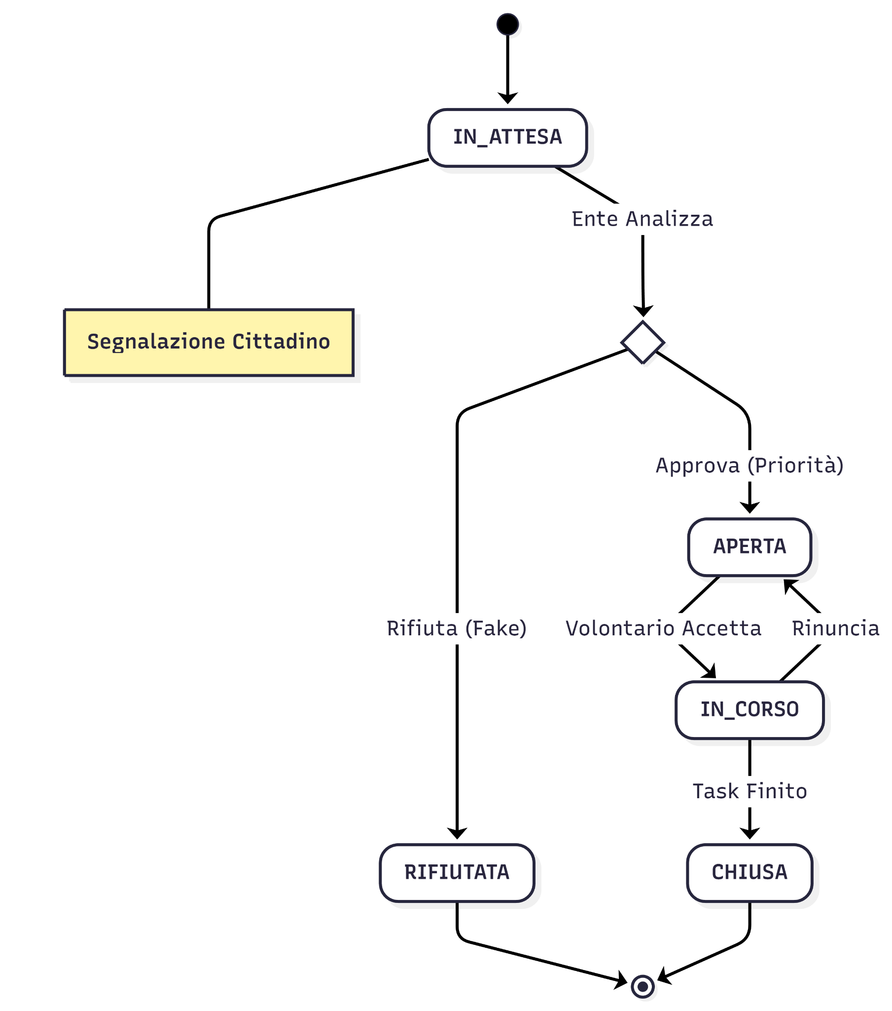

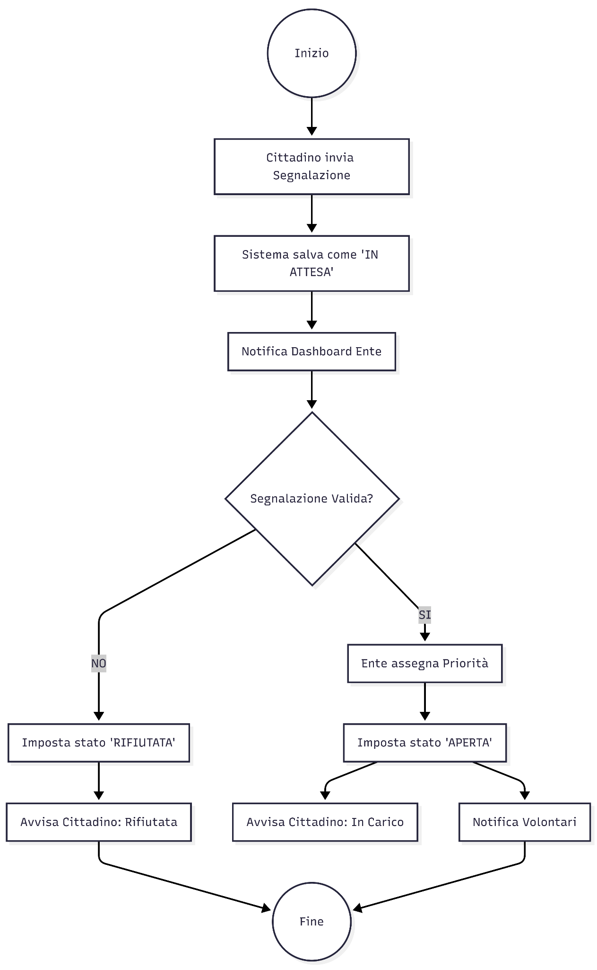
3. Activity Diagram

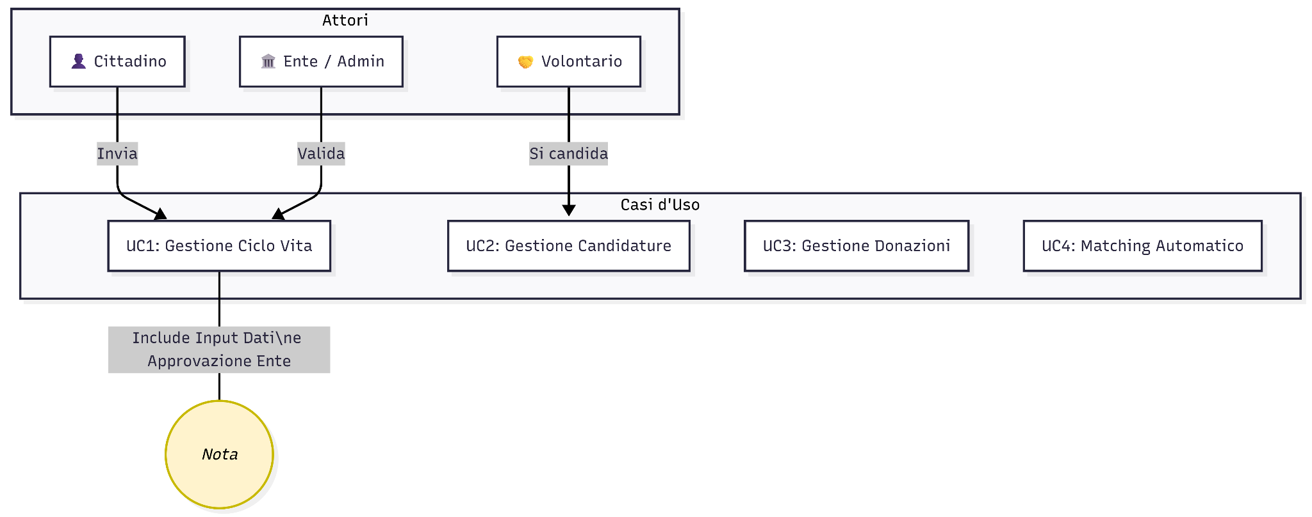
4. Use Case Diagram (Per RAD)

